1. SQL Developer 실행 및 DB 접속
2. 교재 준비
3. 공유 폴더 접근

------------------------------------------------------------------------------

SELECT *

FROM TID ;

SELECT *

FROM TACCT ;

문법에 따른 구분

- ORACLE JOIN : 테이블을 쉼표(,)로 구분, WHERE 절에 조인 조건 정의

- ANSI JOIN : 테이블을 키워드(JOIN)로 구분, ON 절에 조인 조건 정의

SELECT * FROM EMP ;

SELECT * FROM DEPT ;

SELECT *

FROM EMP, DEPT

ORDER BY 1 ;

SELECT *

FROM EMP , DEPT

WHERE EMP.DEPTNO = DEPT.DEPTNO ;

-- ORACLE JOIN

SELECT *

FROM TID I

,TACCT A

WHERE I.LNID = A.LNID ;

-- ANSI JOIN

SELECT *

FROM TID A

JOIN TACCT B

ON A.LNID = B.LNID ;

---------------------------------------------------

SELECT * FROM TREPAY ;

SELECT * FROM TREPAY ORDER BY 1, 2, 3 ;

-- 잘못된 조인

SELECT B.LNACT, B.LNACT_SEQ, B.LN_DT, B.LN_AMT, C.*

FROM TACCT B

JOIN TREPAY C

ON B.LNACT = C.LNACT

ORDER BY B.LNACT, B.LNACT_SEQ, C.SEQ ;

SELECT *

FROM TACCT B

JOIN TREPAY C

ON B.LNACT = C.LNACT

AND B.LNACT_SEQ = C.LNACT_SEQ ;

SELECT *

FROM TACCT B

,TREPAY C

WHERE B.LNACT = C.LNACT

AND B.LNACT_SEQ = C.LNACT_SEQ ;

---------------------------------------------

SELECT *

FROM TID A

,TACCT B

,TREPAY C

WHERE A.LNID = B.LNID

AND B.LNACT = C.LNACT

AND B.LNACT_SEQ = C.LNACT_SEQ ;

SELECT *

FROM TID A

JOIN TACCT B

ON A.LNID = B.LNID

JOIN TREPAY C

ON B.LNACT = C.LNACT

AND B.LNACT_SEQ = C.LNACT_SEQ ;

SELECT * -- ERROR

FROM TID A

JOIN TACCT B

JOIN TREPAY C

ON A.LNID = B.LNID

AND B.LNACT = C.LNACT

AND B.LNACT_SEQ = C.LNACT_SEQ ;

--------------------------------------------------

SELECT *

FROM EMPLOYEES ;

SELECT *

FROM DEPARTMENTS ;

SELECT *

FROM EMPLOYEES E

,DEPARTMENTS D

WHERE E.DEPARTMENT_ID = D.DEPARTMENT_ID ;

SELECT *

FROM EMPLOYEES E

JOIN DEPARTMENTS D

ON E.DEPARTMENT_ID = D.DEPARTMENT_ID ;

-----------------------------------------------------------

SELECT *

FROM EMPLOYEES E INNER JOIN DEPARTMENTS D

ON E.DEPARTMENT_ID = D.DEPARTMENT_ID ;

SELECT *

FROM EMPLOYEES E LEFT OUTER JOIN DEPARTMENTS D

ON E.DEPARTMENT_ID = D.DEPARTMENT_ID ;

SELECT *

FROM EMPLOYEES E RIGHT OUTER JOIN DEPARTMENTS D

ON E.DEPARTMENT_ID = D.DEPARTMENT_ID ;

SELECT *

FROM EMPLOYEES E FULL OUTER JOIN DEPARTMENTS D

ON E.DEPARTMENT_ID = D.DEPARTMENT_ID ;

---------------------------------------------------------------

SELECT *

FROM EMPLOYEES E LEFT OUTER JOIN DEPARTMENTS D

ON E.DEPARTMENT_ID = D.DEPARTMENT_ID ;

SELECT *

FROM EMPLOYEES E

,DEPARTMENTS D

WHERE E.DEPARTMENT_ID = D.DEPARTMENT_ID (+) ;

SELECT *

FROM EMPLOYEES E RIGHT OUTER JOIN DEPARTMENTS D

ON E.DEPARTMENT_ID = D.DEPARTMENT_ID ;

SELECT *

FROM EMPLOYEES E

,DEPARTMENTS D

WHERE E.DEPARTMENT_ID (+) = D.DEPARTMENT_ID ;

SELECT * -- ERROR

FROM EMPLOYEES E

,DEPARTMENTS D

WHERE E.DEPARTMENT_ID (+) = D.DEPARTMENT_ID (+) ;

SELECT *

FROM EMP, DEPT ;

SELECT *

FROM EMP CROSS JOIN DEPT ;

---------------------------------------------------------------------

SELECT employee_id, last_name, salary, job_id, department_id

FROM employees

WHERE salary > (SELECT salary

FROM employees

WHERE employee_id = 107) ;

SELECT employee_id, last_name, salary, job_id, department_id -- ERROR

FROM employees

WHERE salary > (SELECT salary, DEPARTMENT_ID

FROM employees

WHERE employee_id = 107) ;

SELECT employee_id, last_name, salary, job_id, department_id

FROM employees

WHERE salary > (SELECT salary

FROM employees

WHERE employee_id = 107) ;

SELECT employee_id, last_name, salary, job_id, department_id -- ERROR

FROM employees

WHERE salary = (SELECT MIN(salary)

FROM employees

GROUP BY DEPARTMENT_ID) ;

SELECT employee_id, last_name, salary, job_id, department_id

FROM employees

WHERE salary > (SELECT AVG(salary)

FROM employees) ;

SELECT department_id, SUM(salary)

FROM employees

GROUP BY department_id

HAVING SUM(salary) > (SELECT AVG(SUM(salary))

FROM employees

GROUP BY department_id);

SELECT employee_id, last_name, salary, job_id, department_id

FROM employees

WHERE salary IN (SELECT MIN(salary)

FROM employees

GROUP BY department_id) ;

SELECT employee_id, last_name, salary, job_id, department_id

FROM employees

WHERE salary >ANY (SELECT AVG(salary)

FROM employees

GROUP BY department_id) ;

SELECT *

FROM EMP E

WHERE SAL > 2000 ;

SELECT *

FROM EMP E

WHERE E.SAL > 2000 ;

SELECT * -- ERROR

FROM EMP E

WHERE EMP.SAL > 2000 ;

SELECT e.employee_id, e.last_name, e.salary, e.job_id, e.department_id, a.avg_sal

FROM employees e

JOIN (SELECT department_id, AVG(salary) AS AVG_SAL

FROM employees

GROUP BY department_id) a

ON e.department_id = a.department_id ;

SELECT e.employee_id, e.last_name, e.salary,

e.job_id, e.department_id, a.avg_sal

FROM employees e

JOIN (SELECT department_id, AVG(salary) AS AVG_SAL

FROM employees

GROUP BY department_id) a

ON e.department_id = a.department_id

AND E.SALARY > A.AVG_SAL ;

----------------------------------------------------

SELECT employee_id, last_name, salary, job_id, department_id

FROM employees

WHERE (SELECT AVG(salary)

FROM employees) < salary ;

--------------------------------------------------------

-- SELF JOIN

SELECT E.EMPLOYEE_ID, E.LAST_NAME, E.SALARY, E.JOB_ID, E.DEPARTMENT_ID,

S.EMPLOYEE_ID, S.SALARY

FROM EMPLOYEES E

JOIN EMPLOYEES S

ON E.SALARY > S.SALARY

WHERE S.EMPLOYEE_ID = 107 ;

SELECT E.EMPLOYEE_ID, E.LAST_NAME, E.SALARY, E.JOB_ID, E.DEPARTMENT_ID,

S.EMPLOYEE_ID, S.SALARY

FROM EMPLOYEES E

JOIN (SELECT *

FROM EMPLOYEES

WHERE EMPLOYEE_ID = 107) S

ON E.SALARY > S.SALARY ;

1. **2010년 이후 설립된 '신용상태 양호','신용상태 적절' 등급의 법인 차주 정보를 검색하세요.**

- TID(차주정보), TCODE(신용등급 정보) 테이블 사용

- 등급 설명(TCODE.GRADE_DESC)을 함께 검색

- 설립일(BTHDAY)을 기준으로 오름차순 정렬

**검색 결과**

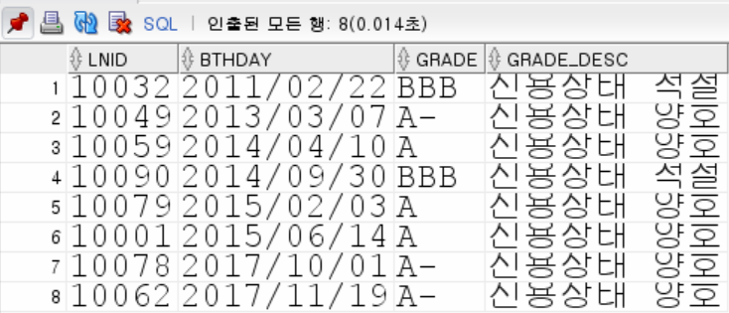

SELECT A.LNID, A.BTHDAY, A.GRADE, B.GRADE_DESC

FROM TID A

JOIN TCODE B

ON A.GRADE = B.GRADE

WHERE A.BTHDAY >= '2010/01/01'

AND B.GRADE_DESC in ('신용상태 양호','신용상태 적절')

ORDER BY A.BTHDAY;

SELECT A.LNID, A.BTHDAY, A.GRADE, B.GRADE_DESC

FROM TID A

,TCODE B

WHERE A.GRADE = B.GRADE

AND A.BTHDAY >= '2010/01/01'

AND B.GRADE_DESC in ('신용상태 양호','신용상태 적절')

ORDER BY A.BTHDAY;

**SELECT A.LNID, A.BTHDAY, A.GRADE, B.GRADE_DESC**

**FROM TID A**

**JOIN (SELECT GRADE, GRADE_DESC**

**FROM TCODE) B**

**on A.GRADE = B.GRADE**

**WHERE A.BTHDAY > '20100101'**

**and B.GRADE_DESC in ('신용상태 양호','신용상태 적절')**

**ORDER BY A.BTHDAY;**

1. **다음 요구 조건에 만족하는 행을 검색하세요.**

- TACCT(대출계좌), TCREDIT(신용평가정보), TCODE(신용등급 코드) 테이블을 사용

- 한도 계좌 제외 검색 (TACCT.LMT_TYP:NULL)

- '04'(TCREDIT.ACODE) 평가사에서 '신용상태 우수'(TCODE.GRADE_DESC) 등급의 신용 평가를

받은 차주 검색

- 신용평가 만료일(TCREDIT.END_DT)이 오늘 이후인 평가만 사용

- 검색 결과는 계좌번호, 계좌일련번호를 기준으로 오름차순 정렬

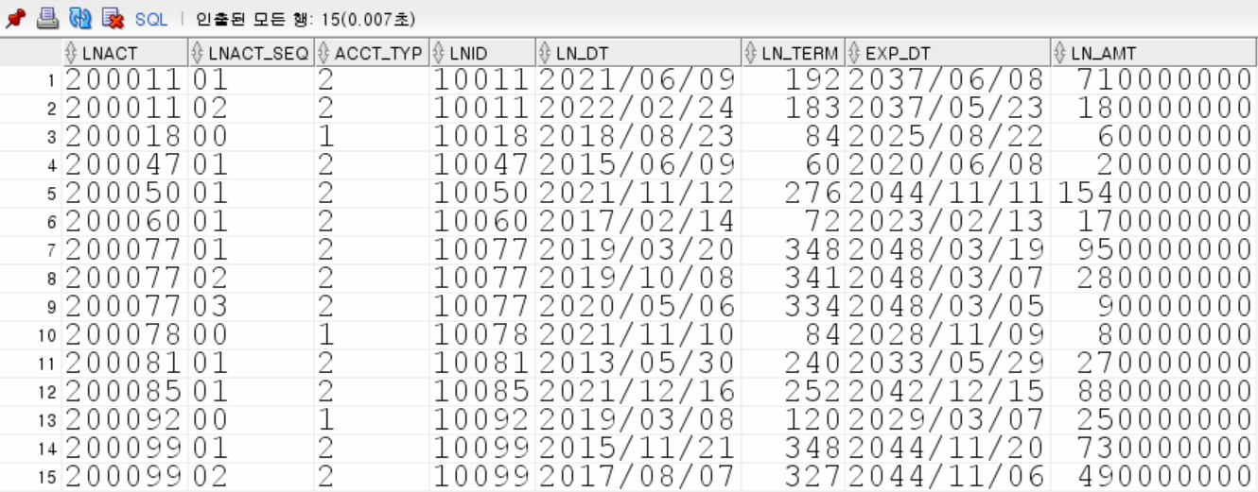

SELECT a.lnact, a.lnact_seq, a.acct_typ, a.lnid, a.ln_dt, a.ln_term,

a.exp_dt, a.ln_amt

FROM tacct a

JOIN tcredit b

ON a.lnid = b.lnid

JOIN tcode c

ON b.code = c.code

WHERE a.lmt_typ IS NULL

AND b.acode = '04'

AND b.end_dt > SYSDATE

AND c.grade_desc = '신용상태 우수'

ORDER BY a.lnact, a.lnact_seq ;

SELECT A.LNACT, A.LNACT_SEQ, A.ACCT_TYP, A.LNID, A.LN_dT,

A.LN_TERM, A.EXP_DT, A.LN_AMT

FROM TACCT A

JOIN (SELECT LNID, CODE, ACODE, END_DT

FROM TCREDIT) B ON A.LNID = B.LNID

JOIN (SELECT CODE, GRADE, GRADE_DESC

FROM TCODE) C ON B.CODE = C.CODE

WHERE A.LMT_TYP IS NULL

AND B.ACODE = '04'

AND C.GRADE_DESC = '신용상태 우수'

AND B.END_DT >= SYSDATE

ORDER BY A.LNACT, A.LNACT_SEQ;

SELECT A.LNACT, A.LNACT_SEQ, A.ACCT_TYP,

A.LNID, A.LN_DT, A.LN_TERM, A.EXP_DT, A.LN_AMT

FROM TACCT A JOIN TCREDIT B

ON A.LNID = B.LNID JOIN TCODE C

ON B.CODE = C.CODE

WHERE A.LMT_TYP IS NULL

AND B.ACODE = '04'

AND B.END_DT >= '20220514'

AND C.GRADE_DESC = '신용상태 우수'

ORDER BY A.LNID, A.LNACT_SEQ;

select t.lnact, t.lnact_seq, t.acct_typ, tc.lnid, ln_dt, ln_term, exp_dt, ln_amt

from tacct t

join tcredit tc

on t.lnid = tc.lnid

join tcode tco

on tc.code = tco.code

where t.lmt_typ is null

and tc.acode = '04'

and tco.grade_desc = '신용상태 우수'

and tc.end_dt > sysdate

order by t.lnact, t.lnact_seq;

**답안**

SELECT lnact, lnact_seq, acct_typ, lnid, ln_dt, ln_term, exp_dt, ln_amt

FROM tacct

WHERE lmt_typ IS NULL

AND lnid IN (SELECT lnid

FROM tcredit

WHERE acode = '04'

AND end_dt > SYSDATE

AND code IN (SELECT code

FROM tcode

WHERE grade_desc = '신용상태 우수'))

ORDER BY lnact, lnact_seq ;